Communications Pack – Research Priority Setting in Bronchiectasis

About the communications pack:
Lung Foundation Australia staff have developed this Communication Pack to assist the Expert Steering Committee to disseminate the initial prioritisation research survey and the WBC Professional Workshop within patients and professional networks. The communications can be directed to professional organisational platforms or personal accounts (i.e. LinkedIn). The pack includes ‘copy’ (provided text) and social media ‘tiles’ (images) for different media communications and platforms.
This pack includes:
- Electronic Direct Mail (EDM/Email) Copy for the Research Survey
- Newsletter Copy for the Research Survey
- Social media copy and tiles for the research survey – can be posted to sites where appropriate i.e. Facebook, X, LinkedIn, or Bluesky
- Social media copy and tiles for the WBC Professional Workshop

EDM Copy
Subject line: Set the Global Bronchiectasis Research Agenda - Complete the Survey Now!
Dear [Name],
Lung Foundation Australia in partnership with international experts and organisations are seeking your thoughts on what you believe researchers should be urgently working on when it comes to bronchiectasis.
Results from this anonymous online survey will be used to identify where researchers, policymakers, and other funding bodies should be directing their attention, time, and resources.
We believe global research priorities in bronchiectasis should be based on the key gaps and needs identified by those who are working each day to prevent and manage this condition, as well as those living with, at-risk of, or impacted by bronchiectasis.
All responses are welcome, and we encourage you to list as many questions, issues or comments as you can.
Please complete this survey if you are:
- Living with bronchiectasis
- A family member or caregiver of someone living with bronchiectasis
- A multidisciplinary health professional working with people impacted by bronchiectasis
- A researcher or academic in respiratory medicine, public health, epidemiology, or related fields
- A representative of a relevant peak body, consumer organisation, or policy/advocacy stakeholder
Every perspective matters, and we can’t do this important work without you. Please help us by completing the anonymous research survey and sharing with your colleagues, patients and networks.
To complete the anonymous online survey or for more information, click the link here
Please read the Explanatory Statement before continuing.
This research project has been approved by Monash University, Melbourne Australia (Project ID: 47463).

Newsletter Copy
Set the global research agenda in Bronchiectasis -
Help shape the future of bronchiectasis research by completing this short, anonymous survey.
As part of a global initiative led by Lung Foundation Australia in partnership with international experts and organisations, the survey aims to identify the most important unanswered questions in bronchiectasis research.
Anyone can participate—whether you're a clinician, researcher, or allied health professional working in the bronchiectasis space. Share as many questions or comments as you like.
Your input will help define an international research agenda and will be discussed at the World Bronchiectasis Conference later this month.
This research project has been approved by Monash University, Melbourne Australia (Project ID: 47463)
Please read the Explanatory Statement before continuing.
Complete the anonymous research survey here

Social Media Copy and Tile – Research Survey
🚨 We need your voice!
Are you a clinician, researcher, allied health professional, or someone impacted by bronchiectasis? Your insights could help shape the future of research and improve lives.
Lung Foundation Australia, in partnership with global experts and organisations, is leading a major international effort to identify the most urgent unanswered questions in bronchiectasis research.
Take our quick, anonymous survey to share what matters most to you. Your input will define a new global research agenda and be discussed at the World Bronchiectasis Conference this month.
This research project has been approved by Monash University, Melbourne, Australia (Project ID: 47463)
Complete the survey now: here
Please read the Explanatory Statement before continuing.
Together, we can change the future of bronchiectasis.
This research is being delivered by Lung Foundation Australia in partnership with:
PCD Australia
COPD Foundation
Bronchiectasis and NTM Association
European Lung Foundation
EMBARC - The European Bronchiectasis Network
EMBARC South Korea
EMBARC India & Indian Chest Society
World Bronchiectasis Day global community and organisations
Other consumer organisations attending and supporting #WBConf25
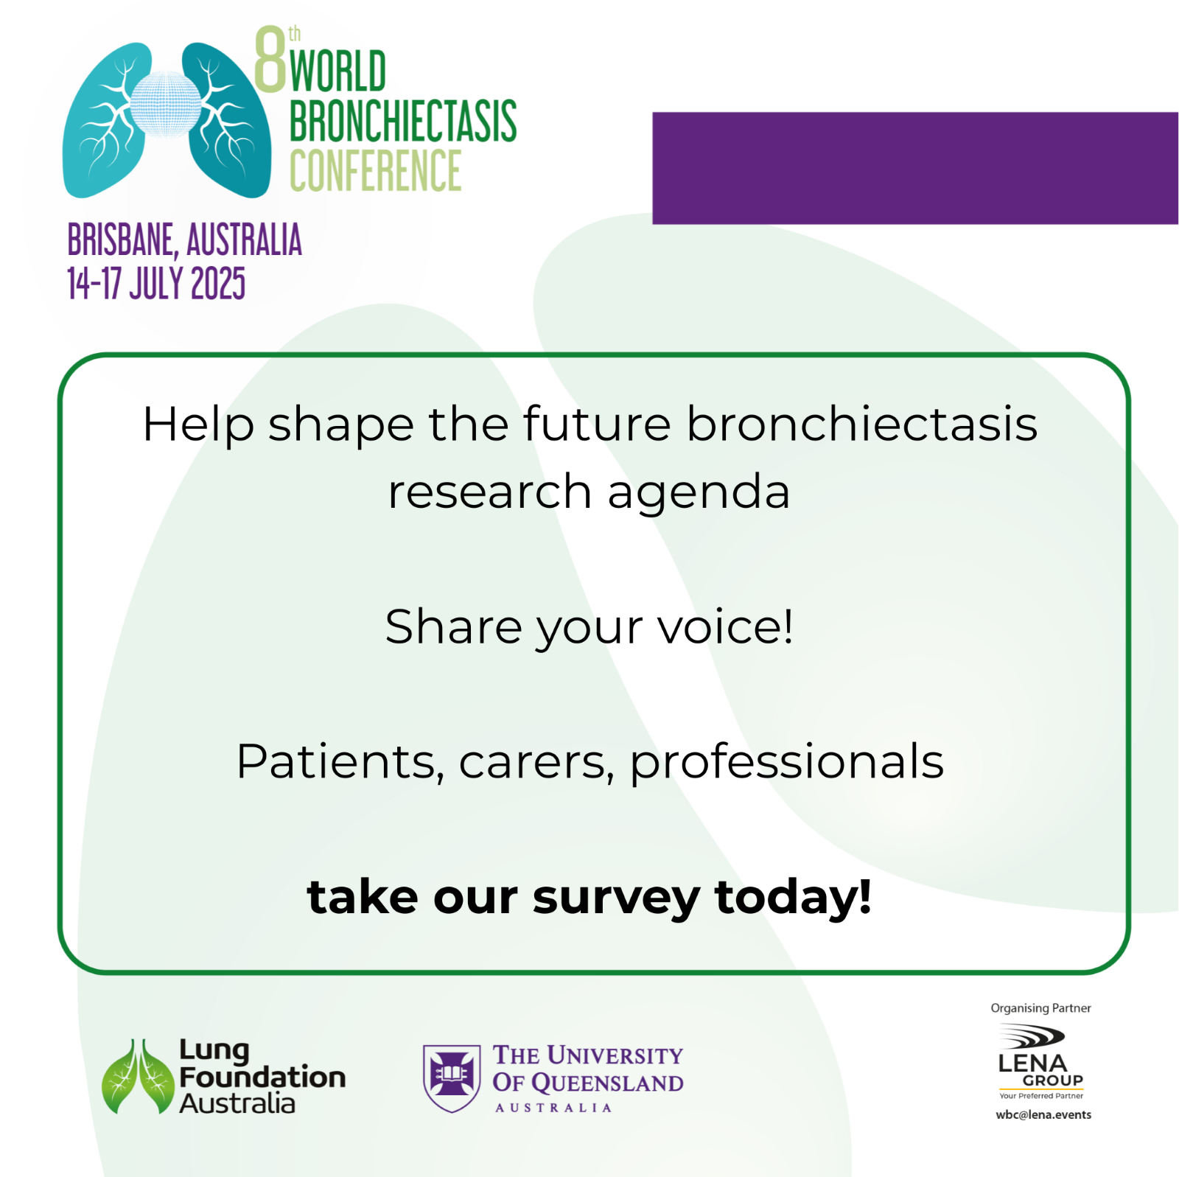

Social Media Copy and Tile – Professional WBC Research Workshop
Calling all clinicians, researchers, allied health professionals, and other key stakeholders!
Help shape the future of bronchiectasis research by joining the Research Priority Setting Workshop on Tuesday 15 July 2025, 8:30 AM – 10:30 AM AEST hosted during #WBConf25.
🔍 This interactive session will bring together global experts to reach consensus on the most urgent research questions facing the bronchiectasis community today.
This workshop is part of a broader international initiative coordinated in partnership with leading organisations and researchers worldwide to help inform the global research agenda.
Please read the Explanatory Statement before continuing.
This research project has been approved by Monash University, Melbourne Australia (Project ID: 47463)
Don't miss your chance to contribute, register now: https://lnkd.in/ew_ryndJ
Workshop is being delivered by Lung Foundation Australia in partnership with:
PCD Australia
COPD Foundation
Bronchiectasis and NTM Association
European Lung Foundation
EMBARC - The European Bronchiectasis Network
EMBARC South Korea
EMBARC India & Indian Chest Society
World Bronchiectasis Day global community and organisations
Other consumer organisations attending and supporting #WBConf25
Kindly note that registering for the Research Priority Setting Workshop does not grant access to the WBC scientific sessions.
